Vincent Foy <revfoy@gmail.com>

Problems with Fully Alive sex education program

Vincent Foy <revfoy@gmail.com> | Thu, Mar 19, 2015 at 12:51 PM
To: XXXXXXXX
Cc: archbishop@archtoronto.org

Dear XXXXX

I am forwarding a copy of this message to Cardinal Collins' secretary in hopes that she will certify that this information is brought to his attention.

Thank you for confirming that the explicit material you sent below from Fully Alive is actually from the student textbook!

I am posting below notes from your recent emails including other direct quotes from Fully Alive with a few of the problems you noticed in square brackets.

I am also attaching the two new photos you sent.

The bolded section directly below quotes Bishop Roman Danylak who recommended removal of and banned the Fully Alive program. I echo his words of wisdom.

There are schools that do not use the Fully Alive sex education program and only use faithful catechism/religion courses like the Faith and Life series and the Catechism of the Catholic Church. Incidentally, the Marian Catechist program is also an excellent resource for an Archdiocesan program of catechesis.

Incidentally, in the near future, I will also be making available a critique of the Born of the Spirit Series which I noted in my article "Catechetical Chaos in Canada: Causes and Cure" on my website.

Msgr. Vincent Foy

Bolded section from Bishop Danylak's website: http://www.sacredheartofjesus.ca/Education/schoolTexts.htm
3. The Fully Alive "Family Life" Education Series
This series is gravely flawed because it deviates from the Church's teaching on family life education. This teaching is set forth in the encyclical of Pope Pius XI On the Christian Education of Youth of Dec. 31, 1929, the Apostolic Exhortation Familiaris consortio (The Christian Family in the Modern World) Nov. 22, 1981, Educational Guidelines in Human Love of the Sacred Congregation for Catholic Education, Nov. 1, 1983 and most recently The Truth and Meaning of Human Sexuality of the Pontifical Council for the Family, Dec. 8, 1995.
The Fully Alive program ignores the latency period of our children and therefore can contribute to the loss of innocence. It gives group instruction in intimate sexual matters although the Church has specifically forbidden this. It is woefully deficient in its treatment of moral principles. It often ignores the Church's teaching on sin and grace and modesty. It does not distinguish between the different degrees of maturity in the same class as the Church tells us teachers must do. It violates the principle of imparting information on sexual matters only at the point of development when this is needed. The Fully Alive program is not a program for formation in Christian virtue but a program of imparting sexual knowledge to children.
A summary of the matters discussed at the Grade 7 level makes clear how this sex education course descends to the level of child abuse. Terms explained include: cervical mucus, acrosome, testosterone, estrogen, progesterone, erection, ejaculation, nocturnal emissions, homosexuality, masturbation, rape, and sexual molestation. In Grade 8 education in methods of contraception, even illicit and abortifacient ones, is given. This education in evil can only promote sexual experimentation and sins. I recommend the booklet From Winnipeg to Fully Alive by Msgr. Vincent Foy for an in depth analysis of the defects and shortcomings of the Fully Alive course.
My recommendation asks that the Fully Alive program be replaced in our schools: all that is necessary can be taught in the context of the Sixth and Ninth Commandments with formation and teaching in the virtues of chastity and modesty and in accordance with the directives of The Truth and Meaning of Human Sexuality, through the solid Faith and Life religion series.
The proper authority in the area of family life education should be with the parents. For parents, the best guidelines for education within the family are The Truth and Meaning of Human Sexuality and The Catechism of the Catholic Church. "Blessed are the pure of heart, for they shall see God" (Matt. 5:8).

------

2015: FULLY ALIVE SEX (FAMILY LIFE) EDUCATION PROGRAM TEACHES GRAPHIC DETAILS TO CHILDREN BEFORE PUBERTY.

Please look at the link below at some of the summaries of what children are taught. Then follows a parent/teacher resource with possible answers to be used in case a student/child has questions.

http://acbo.on.ca/englishdocs/Gd3_ThemeThree_PDF.pdf

Below is a summary quoting from the Fully Alive program, what Grade 3 students are taught:

“Looking Ahead

Terms used in Grade 2 (sperm, ovum, cell, sac, umbilical cord) are reviewed in Grade 3, and the term conception is introduced. The students are given a brief explanation of how babies are born.

Next year, in Grade 4 the student book introduces the term sexual intercourse, but does not include a physical description. The teacher book has a simple explanation of sexual intercourse that may be presented by the teacher to the students, depending on the readiness of the class.

This information is not included in the student book until Grade 5.

Summary

This topic helps the students understand that human life begins with the love of parents. The teacher and students read the first part of a story about the Carson family, and discuss three important events in the life of Mr. and Mrs. Carson. The students are given a sheet to complete at home about important events in the lives of their families. You will find all of the stories featuring the Carson family at the end of this theme.

Main Ideas

• When a man and woman marry, they ask God to bless them and help them to be a good husband and wife.

• One very important way husbands and wives share their love is by becoming parents.

• We are here because of the special love of our parents and because of God’s love.

Summary

This topic helps the students understand that it is part of God’s plan that each human life begins at the moment of conception. The teacher and students continue the story of the Carson family, and talk about how each human life begins as a single cell. The student learn that this tiny cell starts to divide, and before long, the baby’s body begins to develop. To end the topic, the class says a prayer together, thanking God for the gift of life. You will find this prayer at the end of the five themes for Grade 3.

Main Ideas

• We begin life as a tiny cell inside our mothers.

• Conception is the moment when a tiny part from the father (called a sperm) and a tiny part from the mother (called an ovum, or egg) join together inside the mother and become a single cell.

• Conception is the beginning of a new human life. This life comes from God and from the mother and father.

Summary

This topic helps the students understand how babies are born and the special care they need after birth. The teacher and students read the last part of the story of the Carson family. At the end of the topic, the students are given a sheet to complete at home about their birth. They are asked to bring the sheets back to school so that they can share what they learned with the class.

Main Ideas

• The uterus is a large muscle. When it is time for the baby to be born, it starts to push on the baby.

• The bottom of the uterus begins to open, and after a while the baby can move through the opening. The baby moves into the birth canal (vagina), and out into the world.

• New babies need lots of care and love after they are born. They drink milk from the mother’s breasts or from a bottle.”

[BELOW IS THE SUGGESTED ADVICE IN FULLY ALIVE GRADE 3 RESOURCE FOR PARENTS TO INSTRUCT THEIR CHILDREN ABOUT SEXUAL INTERCOURSE IN GRADE 3 -- THEY SHOULD NOT BE ENCOURAGING PARENTS TO DO THIS]:

• This topic provides you with an opportunity to answer questions your child may have and to continue to teach him or her about the beginning of new human life. At school, if the children want to know how the sperm got inside the mother, the teacher is asked to have the children bring that question home. This is because, ideally, children should receive their first explanation of sexual intercourse from you. If you have not already given your child a simple explanation of sexual intercourse you may want to look at the various answers provided for this question at the end of this topic. They are just suggestions. but they may help you to find the right words.

• If your child seems interested and has questions about where the sperm and ovum come from, this would be a good time to answer. Explain to your child that the father’s sperm is made inside his testicles. The testicles are inside the scrotum, which is a sac of skin under the penis. The mother’s ovum comes from her ovaries, which are inside her body, near the uterus. If your child is a boy, you could tell him that when he is older, his body will start to make sperm so that when he is grown up, he could be a father. If your child is a girl, you might tell her that when she is older, her ovaries will begin to ripen ova (ova is the plural of ovum) so that when she is grown up, she could be a mother.

[HERE ARE SOME SUMMARIES FROM THE GRADE 6 RESOURCE. A PARENT SAW THE ACTUAL GRADE 6 COPY WHEN HER SON BROUGHT IT HOME. IT DOES HAVE A DETAILED DESCRIPTION OF SEXUAL INTERCOURSE, AS WELL AS A DIAGRAM OF THE ENTIRE UTERUS NAMING ALL PARTS (VULVA, VAGINA ETC.) AND A DIAGRAM OF A PENIS (ALL NAMES, SCROTUM, SAC, PENIS ETC.)]

In Theme Three we will

• explore some of the ways in which we learn about sexuality and develop our ideas about what it means to be male or female.

• review the main features of adult female and male fertility.

• learn about the first minutes and days of a new human life, the development of the new life during each trimester of a pregnancy, and the baby’s birth.

• discuss some physical, emotional, and social changes related to puberty.

• examine how both heredity and environment influence our development as persons, and learn about the choices we can make as we develop.

The only new term in Grade 6 related to the male and female reproductive system and fertility is menopause. Other new terms related to fetal development, pregnancy, and birth include nucleus,
membrane, DNA, chromosome, gene, zygote, embryo, fetus, trimester, and labour. These terms are used to explain the process through which two life-giving cells, the sperm and ovum, unite
and exchange genetic information, the development of new life during nine months of pregnancy, and the birth of the baby.

This theme also introduces in a more direct way our calling to be loving and life-giving according to our state of life. Only married people are meant to express their sexuality in an intimate physical relationship. Attraction between the sexes, which begins at puberty and for many people leads to marriage, is also discussed briefly at this grade level. These are topics that are developed more fully in Grades 7 and 8.

Working together at school and at home

• At school, the students will be completing and bringing home several sheets about human fertility, the development of a new life in the uterus, and the changes of puberty. On some of these sheets, there is a section for any questions the students still have about these topics. Be sure to ask your child about questions he or she may have. Some children are uncomfortable asking questions at school and prefer to ask at home. You will find detailed information about the topics in this theme in the Online Family Edition of Fully Alive (www.acbo.on.ca).

• The students will be discussing some important ideas about sexuality, which you may want to find an opportunity to discuss with your child. These ideas include: sexuality is not just about
bodies or body parts, but also about persons who are created by God as males and females. A Christian view of sexuality is that men and women are meant to respect and support each other, not use each other in casual sexual relationships.

This topic helps the students grow in their understanding of sexuality as both loving and lifegiving.

The teacher and students examine the choices people have as they mature and review the life-giving aspect of the gift of sexuality — female and male fertility.

Main Ideas

• Attraction between the sexes begins at puberty and for many people leads eventually to marriage.

• We are all called to be loving and life-giving, but only married people are meant to express their sexuality in an intimate physical relationship.

[MARCH 26, 2015, CORRECTION NOTE: NO SPECIFIC MENTION OF SEXUAL SIN IS MADE HERE].

• Sexual intercourse is a sign of the loving and life-giving relationship of husband and wife.

• Together, men and woman have the physical capacity to give life, a capacity we call fertility.

Main Ideas

• A normal pregnancy lasts about nine months. Each three-month period of the pregnancy is called a trimester. During these trimesters, the various body systems develop, the baby gains height and weight, and, at the end of the last trimester, is ready to be born.

• The process of labour happens in three stages. The first stage begins with contractions of the uterus, which push the baby’s head against the cervix until it opens. In the second stage, the baby moves into the birth canal, and the mother pushes the baby out. In the last stage, the contractions of the uterus push out the placenta.

• The gift of new life is an event to be celebrated and appreciated."

http://acbo.on.ca/englishdocs/Gd6.FamEdTh3.final.pdf

---------- Forwarded message ----------
From: <XXXXXX
Date: Wed, Mar 18, 2015 at 510 PM
Subject: Re: fully alive grade 5 and 6
To: Vincent Foy <revfoy@gmail.com>
Dear Monsignor,
The pictures I sent are from the actual student text book, and yes I agree that although there are 'some' good aspects of the book, it is awful and inappropriate. The lesbian Rachel Carson and advocate for sterilization are also in the actual text book (although their stories are not mentioned, it is very easy for a child in grade 5 or 6 to go online to research their life story)
I am not sure if you read the email I actually did find Jesus as the model of commitment, on the very last page of the chapter on commitment, (I don't know why non-Catholic figures were used, such as Dalai Lama and others) wouldn't it be a wonderful service, example to show the kids outstanding Catholics, again dear Msgr. I hope that this is not adding to your suffering, we are praying for you.
Sincerely,

xxx

From: Vincent Foy <revfoy@gmail.com>
To:
Cc: tcollins@archtoronto.org
Sent: Wednesday, March 18, 2015 4:49 PM
Subject: Re: fully alive grade 5 and 6

Dear XXXXX

Thank for contacting me regarding your efforts to make a critique of the 2012 version of Fully Alive.

From the many detailed emails that you have sent, the program still looks awful and inappropriate. You mentioned below that a lesbian, Rachel Carson, is given as an example of commitment as well as Nellie Mclung, an advocate for sterilization.

Although I am too ill to read all the books to make a thorough critique, I made a preliminary posting on my website recently under Catholic Education:
http://msgrfoy.com/2015/03/12/updated-comments-on-sex-education-march-12-2015/

As you know, I wrote this critique of Fully Alive some years ago:
http://msgrfoy.com/2013/12/17/from-winnipeg-to-fully-alive/

Are the clips you sent below from the current Fully Alive student book or teacher manual?

Thank you for noting that the Fully Alive family resource manuals are on the Association of Ontario Catholic Bishops website: www.acbo.on.ca. It is sad that the program advises parents to discuss the marital act in detail to young children before puberty.

I am forwarding a copy of this message to Cardinal Collins who should be informed of the problems with the current Fully Alive, since he is the one in charge of making sure this program is removed.

Msgr. Foy

On Thu, Mar 12, 2015 at 5:43pm XXXXXXXXXXX wrote:
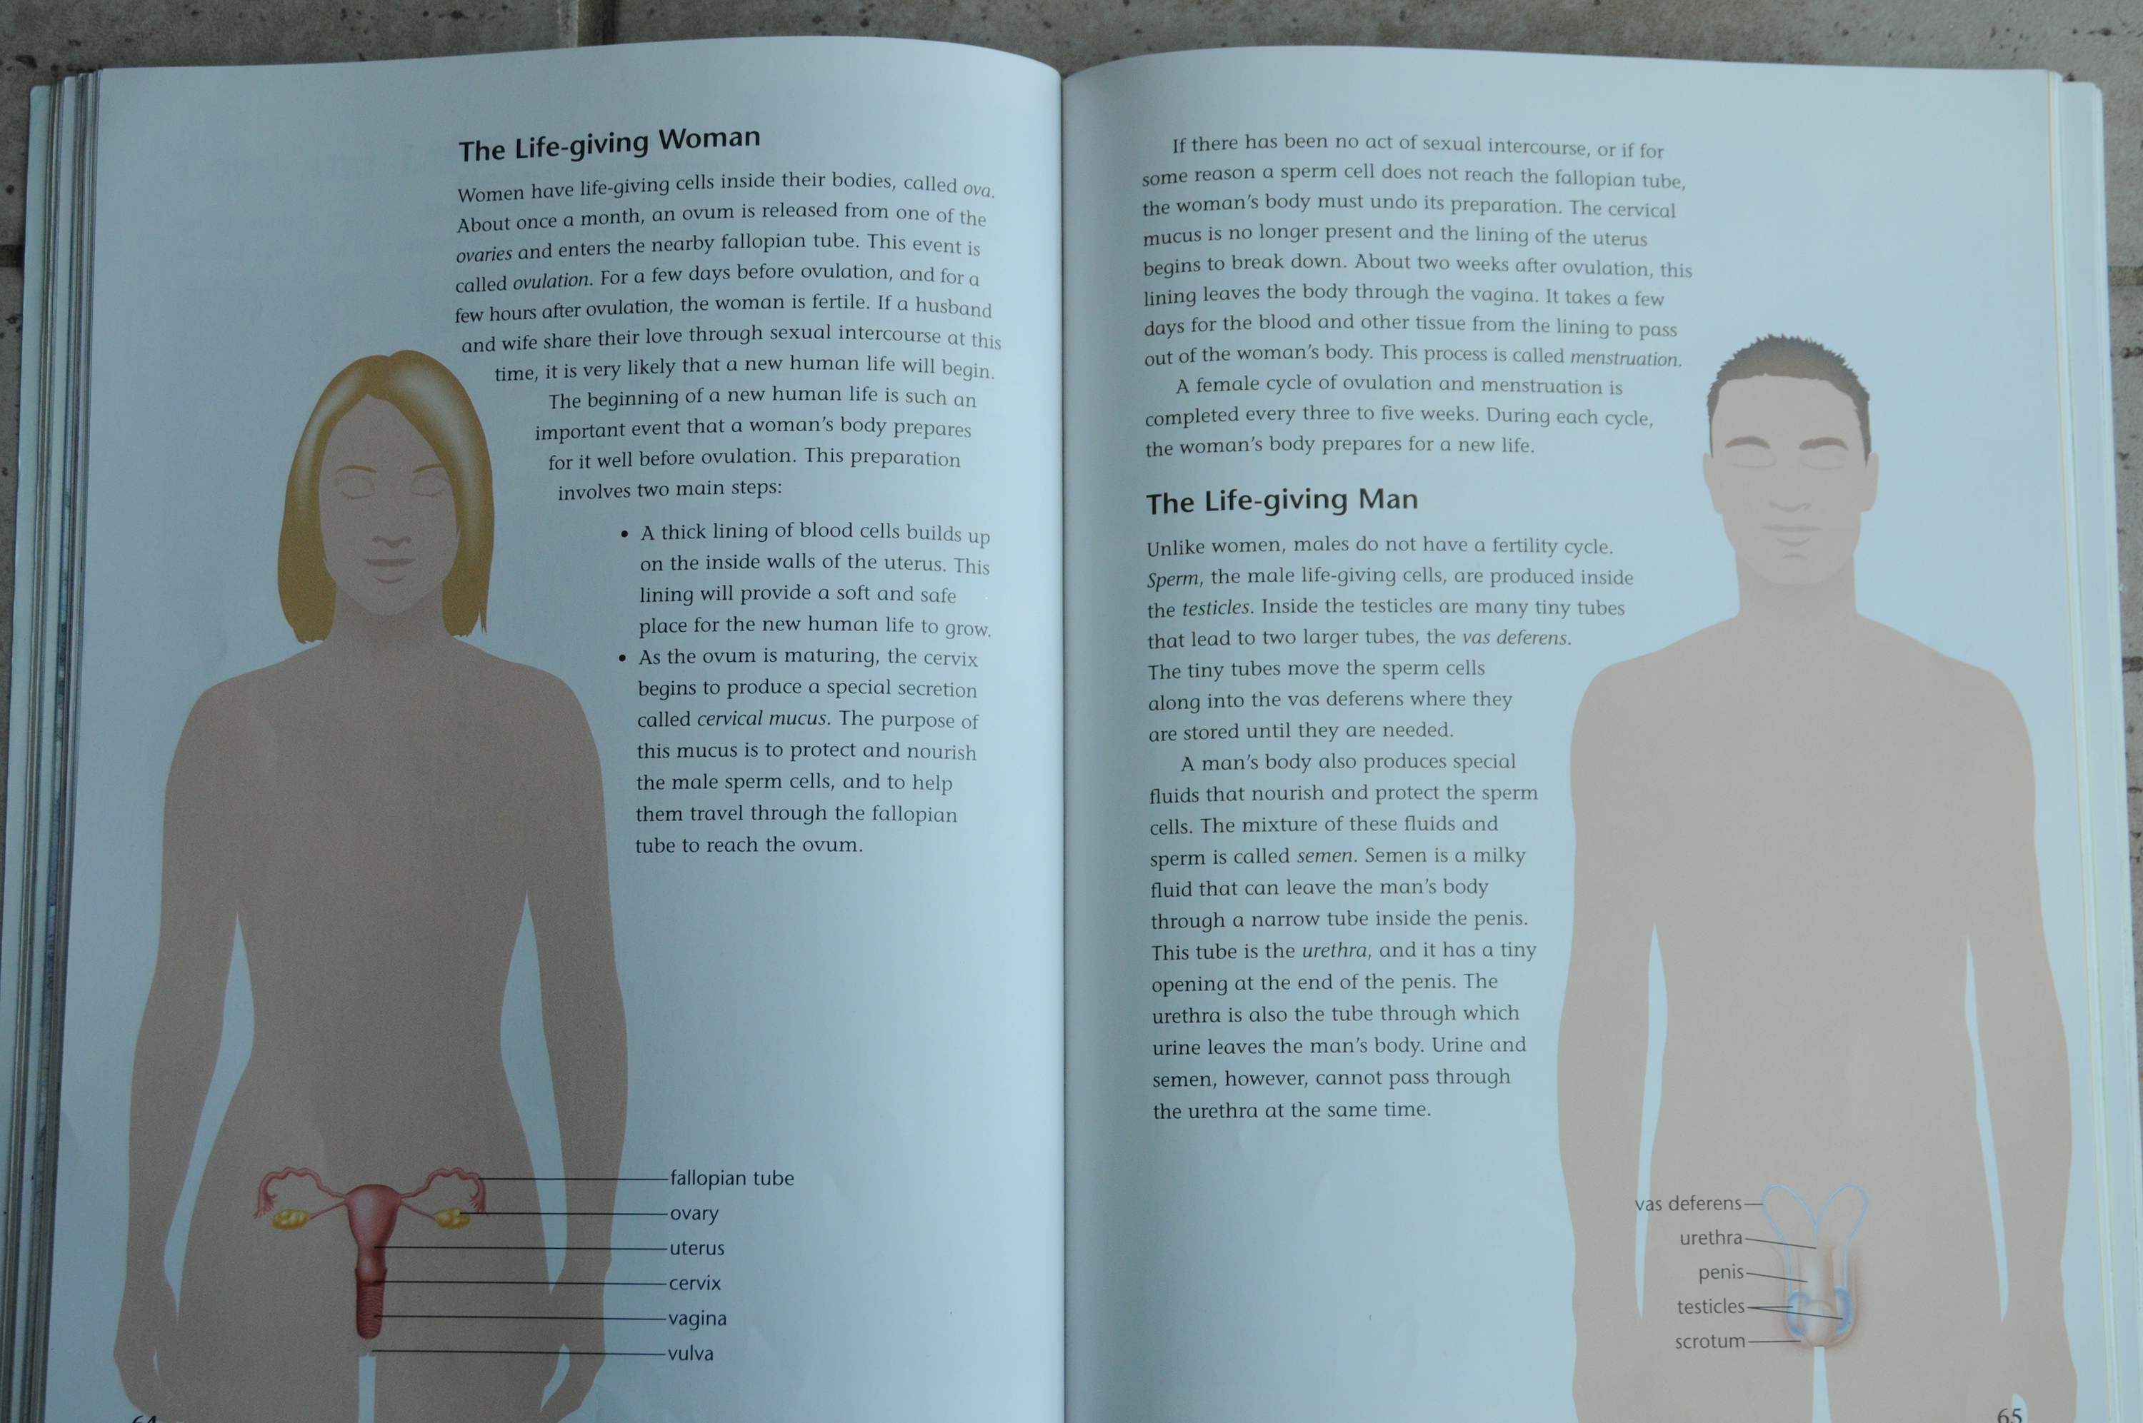
Fully Alive 007 (1).JPG
shared from Dropbox
 |  |  |  | View on www.dropbox.com | Preview by Yahoo
Fully Alive 011 (1).JPG
shared from Dropbox
 |  |  |  | View on www.dropbox.com | Preview by Yahoo

Fully Alive 008 (1).JPG
shared from Dropbox
 |  |  |  | View on www.dropbox.com | Preview by Yahoo
Fully Alive 006 (1).JPG
shared from Dropbox
 |  |  |  | View on www.dropbox.com | Preview by Yahoo

Fully Alive 005 (1).JPG
shared from Dropbox
 |  |  |  | View on www.dropbox.com | Preview by Yahoo
Fully Alive 003 (1).JPG
shared from Dropbox
 |  |  |  | View on www.dropbox.com | Preview by Yahoo

Fully Alive 009 (1).JPG
shared from Dropbox
 |  |  |  | View on www.dropbox.com | Preview by Yahoo
Fully Alive 001 (1).JPG
shared from Dropbox
 |  |  |  | View on www.dropbox.com | Preview by Yahoo

Fully Alive 012 (1).JPG
shared from Dropbox
 |  |  |  | View on www.dropbox.com | Preview by Yahoo
Fully Alive 013 (1).JPG
shared from Dropbox
 |  |  |  | View on www.dropbox.com | Preview by Yahoo

Fully Alive 014 (1).JPG
shared from Dropbox
 |  |  |  | View on www.dropbox.com | Preview by Yahoo
Fully Alive 010 (1).JPG
shared from Dropbox
 |  |  |  | View on www.dropbox.com | Preview by Yahoo

Fully Alive 004 (1).JPG
shared from Dropbox
 |  |  |  | View on www.dropbox.com | Preview by Yahoo
Fully Alive 002 (1).JPG
shared from Dropbox
 |  |  |  | View on www.dropbox.com | Preview by Yahoo

Msgr. here are the pictures again right side up, these are from the grade 5 and grade 6

Good Evening,
I think I mentioned that I will be going page by page, with the two books I now have in my hands (gr.5 FA & gr.6FA) I am on pg. 100 of one of the books. I have finally found Jesus used as an example of "the perfect model of commitment - talks about the price of commitment, the cross which stands for love and suffering, is part of each person's life" - it's a beautiful message and this is what the kids need to hear , but it is at the end of the chapter in the last paragraph. The book in itself has some very good and positive examples for kids to deal with real-life difficult situations, however, is that enough to offset the damage done by the other information, I don't think so and neither do many, many parents.
----- Forwarded Message -----
From: "aniaarleta@yahoo.ca" <aniaarleta@yahoo.ca>
Sent: Sunday, March 15, 2015 8:18 PM
Subject: Questionable examples in FA

RACHEL CARSON

So there is evidence and high rumour that Rachel Carson did have a lesbian affair with a woman who was married, this is one of the examples of commitment in the fully alive book
Mar 12 (6 days ago)
http://www.glbtq.com/social-sciences/carson_r.html

In 1952, at the age of forty-five, Rachel met the great love of her life, DorothyFreeman. Dorothy was fifty-five, very married, and a grandmother. They meton an island in Maine where their families had vacation cottages, and withinmonths their friendship developed into a passionate intimacy. AlthoughDorothy’s husband accepted their relationship, Rachel and Dorothy kept their love a secret to the outside world. For the next ten years, until Rachel’s death, the two women shared their summers on the island, spending the rest of the year five hundred miles apart
https://www.scribd.com/doc/60569561/Rachel-Carson-Breaking-the-Silence#download

THEN WE HAVE NELLIE MCCLUNG AS AN EXAMPLE OF COMMITTMENT

http://www.theglobeandmail.com/news/national/human-rights-lawyer-opposes-honour-for-right-to-vote-pioneer-nellie-mcclung/article1241485/

While Mr. Matas doesn't deny Ms. McClung's influential role in gaining the vote for Canadian women, he does take umbrage at her prominent support of the eugenics movement.
"It was the scientific basis of racism," he said. "The whole eugenics movement is very problematic."
The movement, which espoused selective breeding among humans for the betterment of the species, earned widespread interest during the early 20th century in Canada - even attracting the endorsement of a young Tommy Douglas, who wrote his master's thesis on the subject. By the mid-1930s, it had formed the intellectual basis for the forced sterilization of mental-health patients in Alberta and British Columbia.

THESE PEOPLE SHOULD NOT BE SHOWN AS EXAMPLES OF COMMITTMENT IN A 'CATHOLIC' BOOK REGARDLESS OF THEIR ACCOMPLISHMENTS BECAUSE OF WHAT THEY STOOD FOR -- ONE WAS LEADING A LESBIAN LIFESTYLE WITH A MARRIED WOMAN, THE OTHER WAS AN ADVOCATE FOR STERILIZATION OF THE 'SIMPLE MINDED'
MY POINT AGAIN WHY IS JESUS NOT MENTIONED AS THE GREATEST EXAMPLE OF COMMITMENT...

I HAVE NOT FOUND IT YET WHY ARE THE LIVES OF ANY OF THE SAINTS NOT ONE OF THE STORIES IN THE BOOK, WE HAVE HUNDREDS OF EXAMPLES OF SAINTS, WHY NOT INTRODUCE THESE WONDERFUL EXAMPLES, EXAMPLES WORTH FOLLOWING.

2 attachments
photo 1.JPG
1889K

photo 2.JPG
2143K

